**Identifying the Next Trendy Neighborhood in Brooklyn**

**Michael Granovsky**

**April 20 2020**

**Table of Contents:**

1. **Introduction**
2. **Data**
3. **Method**
4. **Results**
5. **Discussion**
6. **Conculsion**
7. **Introduction:**

An investor want to large amounts of capital into Brooklyn, however he is too cheap to put it already established and trendy neighborhoods, he is looking for a bargain and is willing to put time into his investments in the area that may include real estate and businesses. He wants to find a neighborhood that can become like Park Slope or Williamsburg. For this project I will use kmeans clustering to group neighborhoods together and find similarities.

**Who could be interested in this project:** An investor searching for the next hot thing, Young college educated grads looking for a place to live.

1. **Data:**

My first data set is the rent data for Brooklyn this is a csv from <https://www.rentcafe.com/average-rent-market-trends/us/ny/brooklyn/> and contains two columns the neighborhood and average rent price. The next piece of data I used was the dataset: <https://geo.nyu.edu/catalog/nyu_2451_34572>, containing geographical data on all of New York City The files are revived as json. I rearranged the d data into dataframe with 4 columns**: ['Borough', 'Neighborhood', 'Latitude', 'Longitude'], and then later narrowed it down to only contain the borough of Brooklyn. The last bit of data I needed for this project was the Foursquare location data from the api. This is what I used to segment neighborhoods into clusters to find the similar neighborhoods. The dataframe had 7 columns: [‘Neighborhood', ‘Neighborhood Latitude', ‘Neighborhood Longitude', ‘Venue’, ‘Venue Latitude', ‘Venue Longitude', ‘Venue Category’] Analyze each neighborhood by one hot encoding, grouping rows by neighborhood and taking the mean of the frequency of occurrence of each ‘Venue Category’, and then use k-means to cluster the neighborhood into clusters.**

1. **Method:**

We will use the Foursquare location data to explore and compare Williamsburg and Park Slope to the other neighborhoods of Brooklyn, use the k-means clustering algorithm to find the similar neighborhoods, use the Folium library to visualize the neighborhoods and their clusters. I used the kmeans clustering method. Kmeans is often used for clustering in many data science applications, especially useful if you need to quickly discover insights from unlabeled data. First I got the json data and rent csv as shown below:

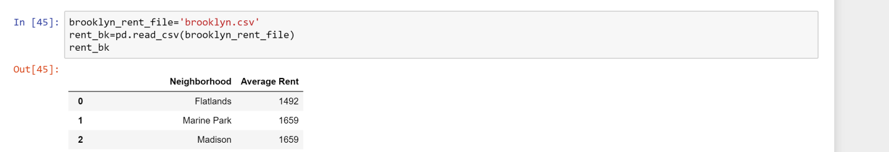

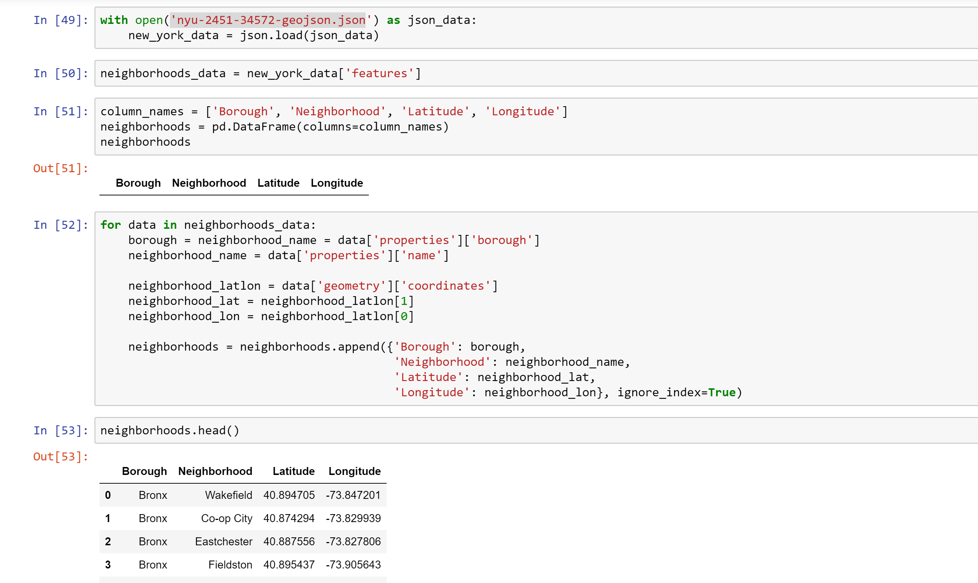

Then I narrowed the data down to just Brooklyn:

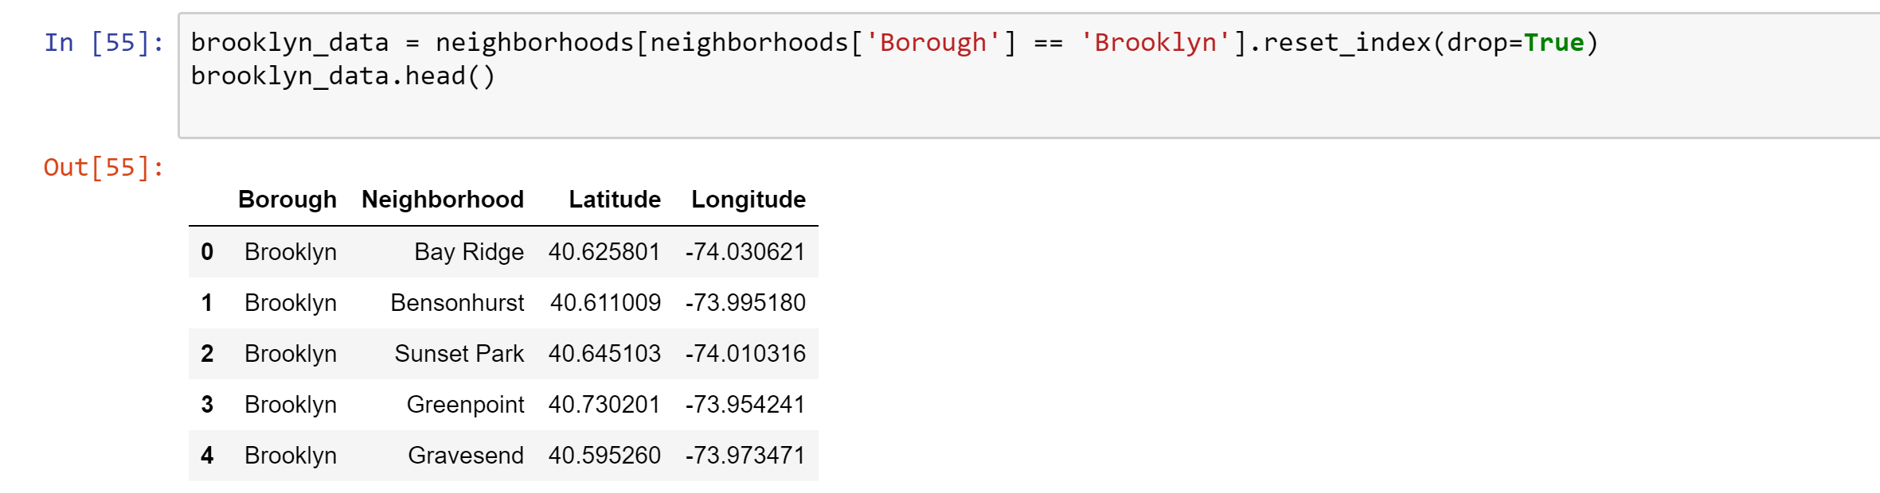

Next I used foursquare to explore the neighborhoods, I transformed the data into dataframe with 7 columns: [‘Neighborhood', ‘Neighborhood Latitude', ‘Neighborhood Longitude', ‘Venue’, ‘Venue Latitude', ‘Venue Longitude', ‘Venue Category’] . Then I used one hot encoding and grouped rows by neighborhood, taking the mean of the frequency of occurrence of each category. Finally comes the clustering. I set the clusters equal to 4, and ran the algorithm and visualized the results. Then I compared the new neighborhoods based on their location, rent and venues.

1. **Results:**

Park Slope and Williamsburg ended up in two different clusters, so I would have to get the two different neighborhoods and compare them.

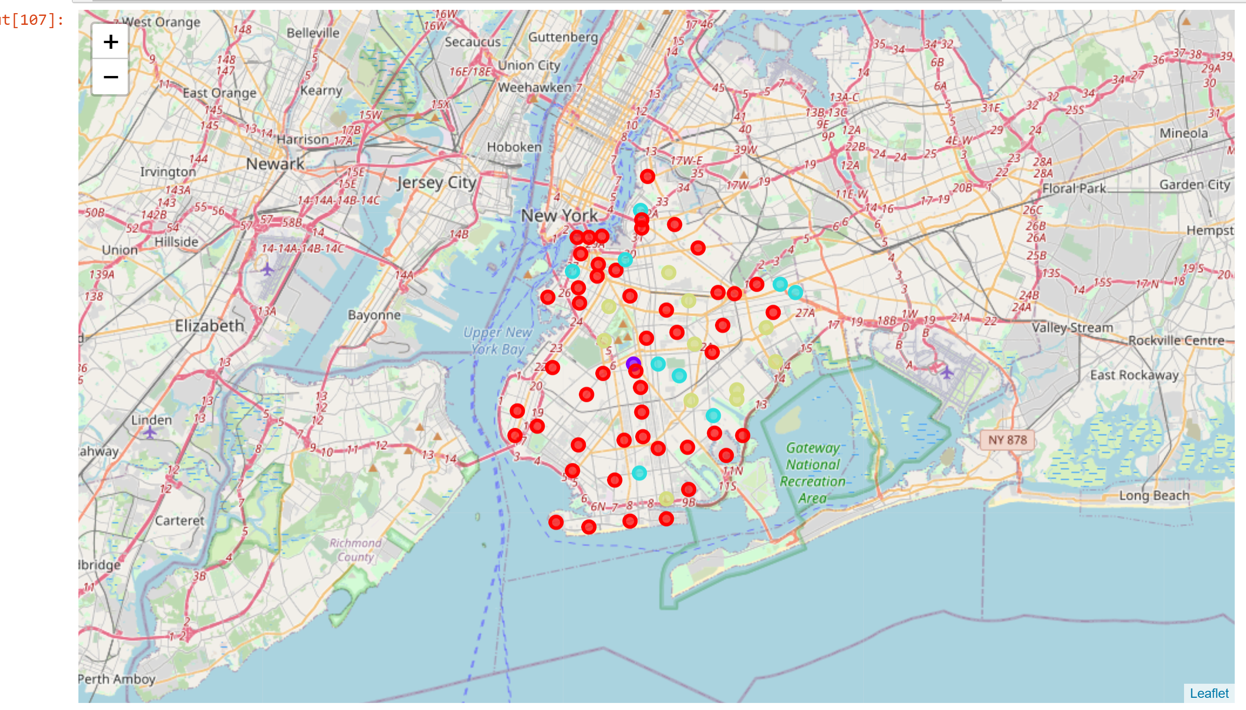

Map of clusters is above with red being cluster 1, purple cluster 2, blue cluster 3, and yellow cluster 4. After comparing by rent my two neighborhoods were Flatlands (from the Park Slope cluster) and Madison (from the Williamsburg cluster). After examining their location and venues,

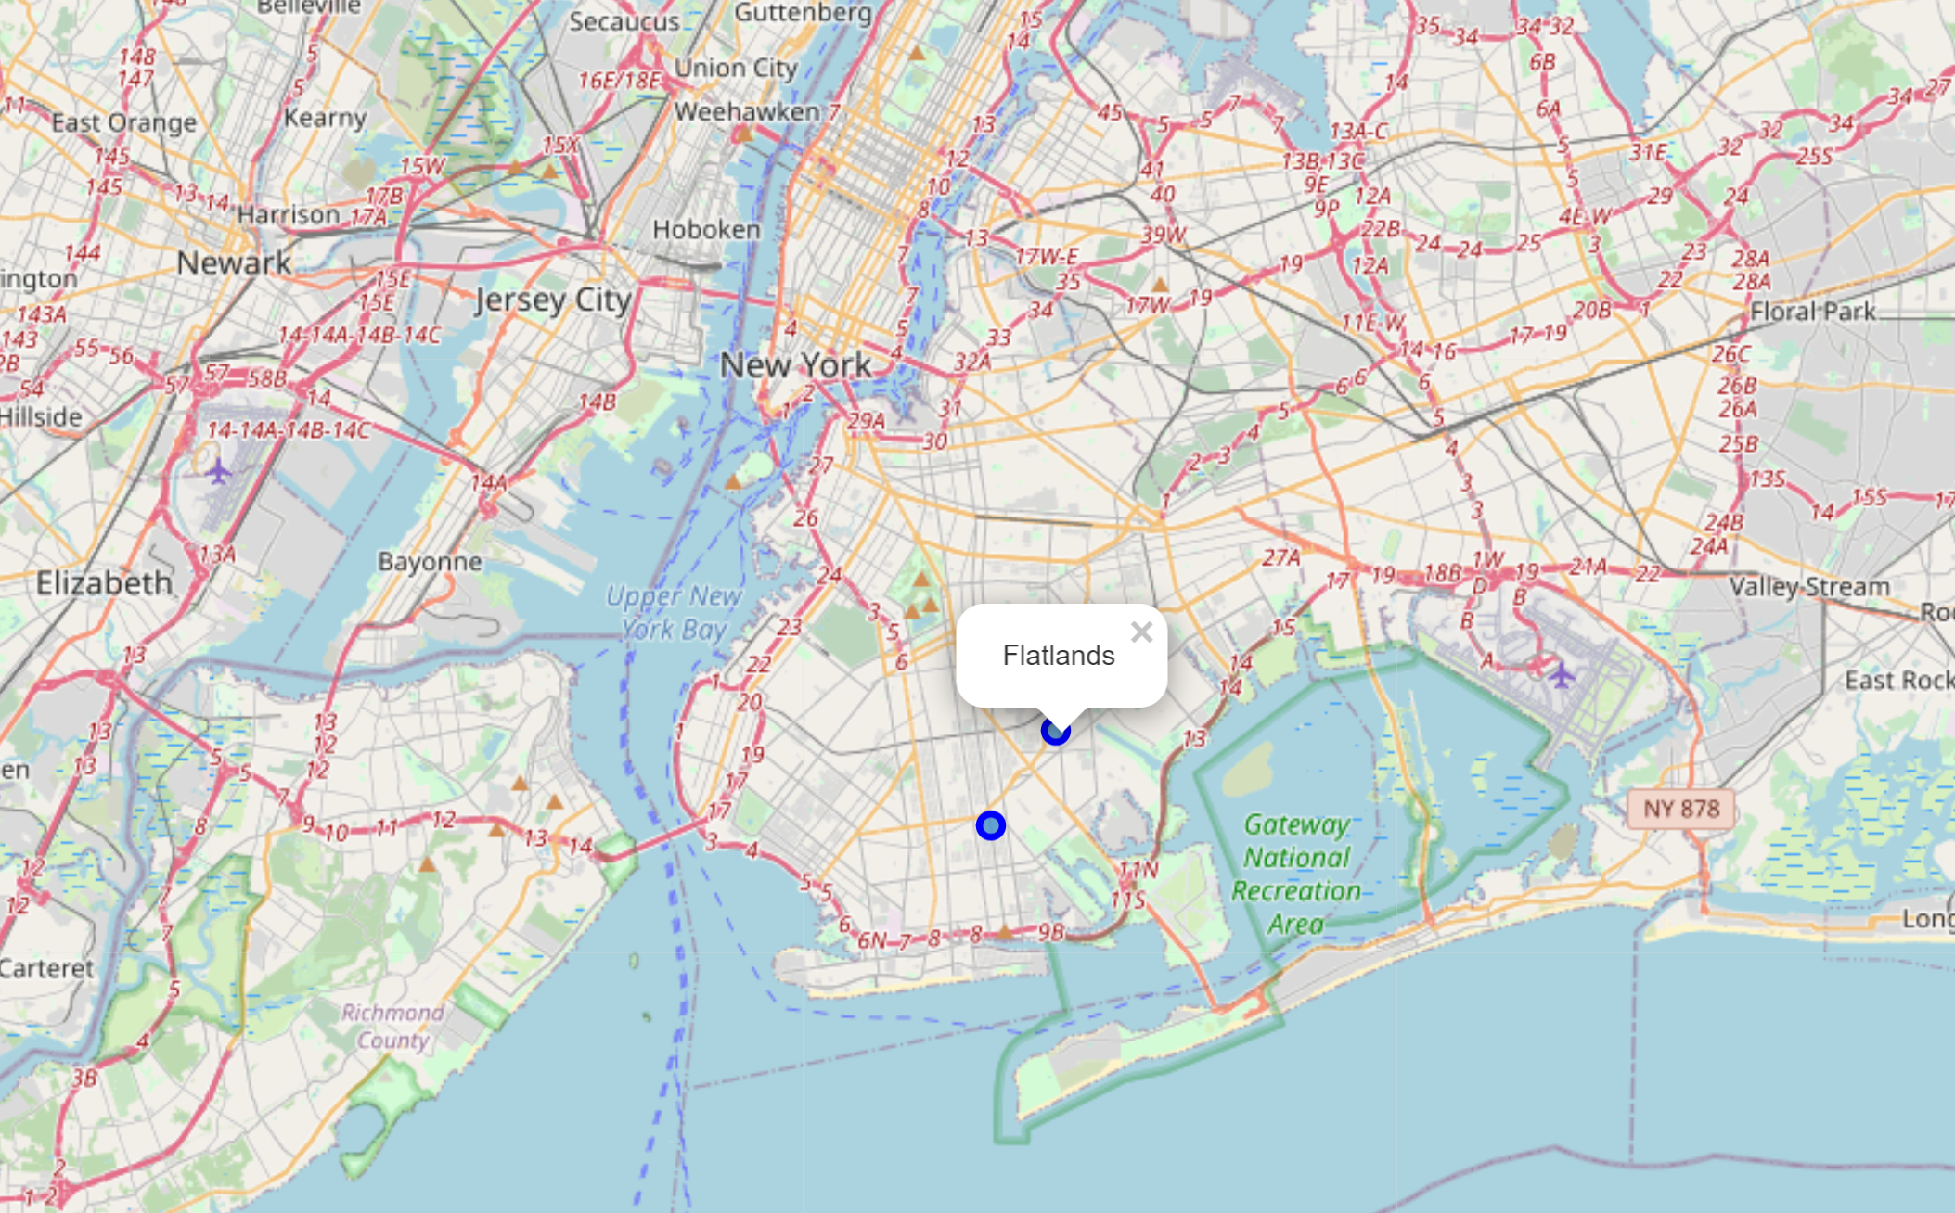

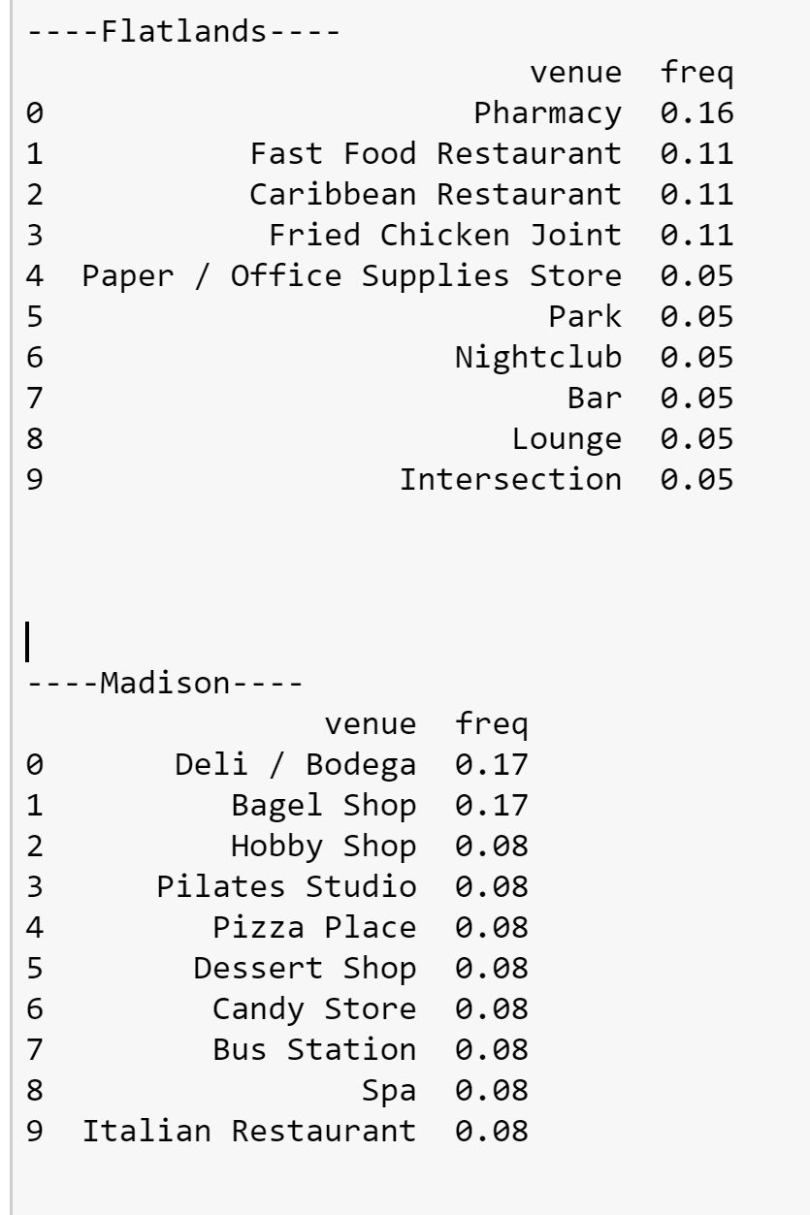

I determined that Flatlands would be the more likely to become trendy due to its more exciting venues and lower rent. However I would present all my data to the investor so he could decide for himself.